Student’s name | …………………………………………………….…… | Grade | 1
Subject | Computer | Week No. | 8
Lesson Title | Need of Computers | Unit
Worksheet No. ( 8 ) (Answer)

write the correct name of each part
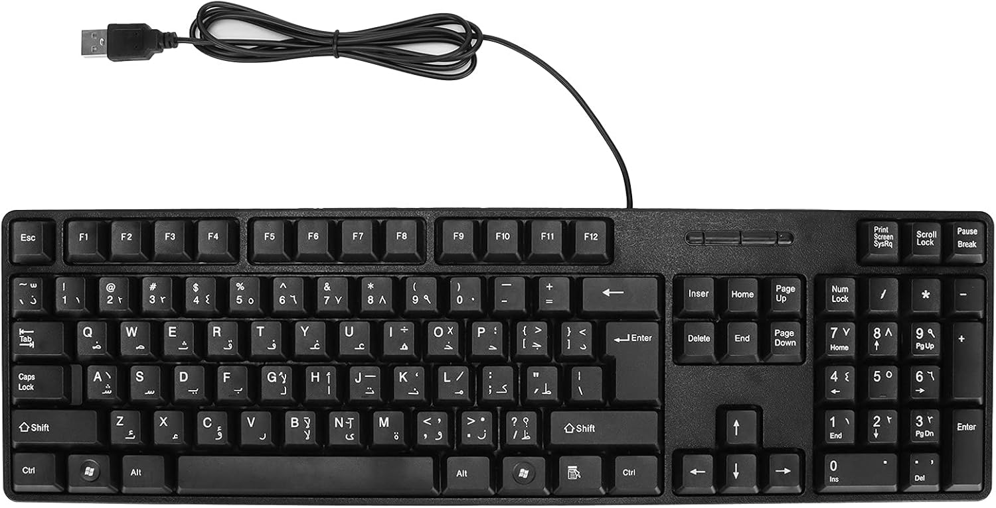


Notepad
keyboard
This PC

Folder
Keyboard
Notepad
This PC
Tablet
Folder
Good Luck

